Vectors are numbers that have magnitude and direction. Eg (displacement, velocity, acceleration, and force.)

Scalars are numbers that have magnitude only and no direction. Eg (distance, speed, energy, pressure, and mass.)

When adding vectors, add tip-to-tail.

Sin θ = $\frac{opposite}{hypotenuse}$

Cos θ = $\frac{adjacent}{hypotenuse}$

Tan θ= $\frac{opposite}{adjacent}$

X = V Cos θ

Y = V Sin θ

Multiplying vectors = A · B = | A | | B | cos θ

Torque = force X lever arm * sin θ == A × B = | A | | B | sin θ

Vector multiplication is not commutative ( A × B ≠ B × A )

Right hand rule: 1) point thumb in vector A direction 2) extend fingers in direction of vector B. 3) direction where palm is now facing is the resultant of vector C.

1.3

Displacement = change in position in space (has both magnitude and direction)

Velocity = (v) is a vector. Measured as the rate of change of displacement in a given unit of time. v = meters/ second.

Force ( F ) is a vector quantity that is experienced as pushing or pulling on objects.

Newton (N) = kg* m / s^2

Gravitational force = $F_{g}= \frac{G m_{1}m_{2}}{r^{2}}$ G= 6.67x10^(-11) N*m^2 / kg^2

Friction = force that opposes the movement of objects.

Static friction $F_{s}$ = friction that exists between a stationary object and the surface which it rests on.   
0 ≤ $f_{s}$ ≤ $μ_{s}$ N

N = normal force $μ_{s}$  
= coefficient of static friction

Kinetic friction $F_{k}$ = $U_{k }N$

$U_{k }$ = coefficient of kinetic friction

N = normal force   
  
mass = scalar (m) has magnitude measured in kg.  
  
weight (Fg) vector measured in N  
  
acceleration (a) = rate of change of velocity as a result of some applied force. a = m/s^2  
  
1.5  
newtons laws  
Fnet= ma =0  
A body either at rest or in motion with constant velocity will remain that way unless a net force acts upon it.

Fnet = ma  
*An object of mass* m *will accelerate when the vector sum of the forces results in some nonzero resultant force vector*.

Fab= - Fba  
*To every action, there is always an opposed but equal reaction*.

1.6  
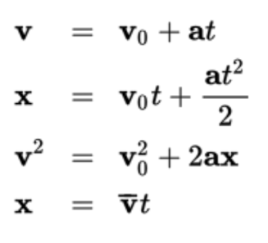  
**Air resistance**, like friction, opposes the motion of an object. Its value increases as the speed of the object increases.

Therefore, an object in free fall will experience a growing **drag force** as the magnitude of its velocity increases.

Eventually, this drag force will be equal in magnitude to the weight of the object, and the object will fall with constant velocity according to Newton’s first law. This velocity is called the **terminal velocity**.

**Projectile motion** is motion that follows a path along two dimensions.   
  
**Circular motion** occurs when forces cause an object to move in a circular pathway. Upon completion of one cycle, the displacement of the object is zero.

**Rotational motion** occurs when forces are applied against an object in such a way as to cause the object to rotate around a fixed pivot point, also known as the **fulcrum**.

Application of force at some distance from the fulcrum generates **torque** (***τ***) or the **moment of force**.

The distance between the applied force and the fulcrum is termed the **lever arm**.

t=rxF= rFsin θ  
  
Torques that generate clockwise rotation are considered negative, while torques that generate counterclockwise rotation are positive.

2.1

**Kinetic energy** is the energy of motion. Objects that have mass and that are moving with some speed will have an associated amount of kinetic energy   
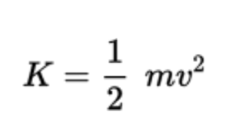 units are joule (J) = 